**The Role of Artificial Intelligence in Genetic: Current and Future Perspective**

**Shafee Ur Rehman1*,.**

<https://orcid.org/my-orcid?orcid=0000-0001-5238-5211>

**Kudaibergen Osmonaliev1**

<https://orcid.org/0009-0008-4469-1065>

**Azamat Makambaev2**

<https://orcid.org/0000-0003-2746-959x>

**Sanzhar Aknazarov1**

<https://orcid.org/0000-0001-8063-8351>

*1Faculty of Medicine, Ala-Too International University Bishkek Kyrgyzstan.*

*International Higher School of Medicine, Bishkek Kyrgyzstan.*

***Corresponding Author:*** *Shafee Ur Rehman PhD, Associate Professor Faculty of Medicine Ala-Too International University.*

*Email:* [*shafeeur.rehman@alatoo.edu.kg*](mailto:shafeeur.rehman@alatoo.edu.kg)

|  |  |
| --- | --- |
| **KEYWORDS**  Artificial intelligence, genomics, molecular medicine and complex data analysis | **ABSTRACT**  The advancement in technology enhance the way of analyzing the nature in more precise and significant way. Among these technologies Artificial intelligence is one the revolutionized technology. The current study was conducted to overview the role of AI in genetics. The AI revolutionized the field of genetics in term of data analysis, future research direction and advance applications in clinical and medical genetics. Basically, the advance sequencing techniques generate huge amount of data, the analysis of these data is slightly difficult hence due to AI application now it is easy to align the data. Further variant identification, functional genomics and molecular medicine the AI play a vital role. AI also enhance the way to edit genome such as CRISPR cas9, designing guide RNA and minimizing off-targeted effect. Furthermore, AI also play critical role in the analysis of complex diseases by analysing genomic, transcriptomic and proteomic data. Moreover, the AI system will enable real time monitoring of gene editing, protection of genomic data, synthesis of biological organism for industrial and medical purposes. Overall, the AI will enhance the genomic research in term of risk prediction, identification of variants, gene editing and molecular medicine. |

**Introduction**

The incorporation of Artificial Intelligence (AI) into genetics is a field that is quickly expanding, despite being relatively new. Breakthroughs in genomic technologies, such as NGS, have led to a vast amount of genetic data being generated [1, 2, 3, 4]. This large amount of data requires advanced computational tools that can process, analyze, and interpret complex genomic information. Conventional bioinformatics methods, although useful, frequently face challenges in handling the large size and intricacy of current genetic data sets [5]. AI, with a focus on machine learning (ML) and deep learning (DL) algorithms, has become a viable solution for addressing these issues [6]. AI's usage in genetics covers a range of areas, including detecting genetic variations and forecasting their effects, as well as enhancing the precision of gene-editing tools such as CRISPR. The rise of precision medicine, which customizes medical treatments based on individual genetic makeup, has underscored the importance of AI. AI has the ability to quickly examine genomic information to pinpoint mutations that cause diseases, estimate how drugs will work, and evaluate the likelihood of developing illnesses like cancer, heart disease, and diabetes [9, 10, 11, 12].

The use of AI in genetics is changing the field, providing new chances for data-driven discoveries, better clinical results, and innovative biotechnological uses [19]. Genetics has transitioned into the age of large data due to the increase in high-throughput technologies such as next-generation sequencing (NGS), resulting in extensive genomic data that necessitates sophisticated computational methods for analysis [20]. Conventional bioinformatics software, although useful, frequently encounter challenges when dealing with the intricate, extensive, and integration requirements of contemporary genetic studies. AI has become a powerful tool in addressing these challenges by learning patterns, making predictions, and optimizing processes [21]. AI is becoming more and more integrated into important areas of genetics, such as genome sequencing, identifying variants, and predicting diseases [22, 23]. AI algorithms, for instance, are utilized to identify and analyze genetic mutations that could lead to illnesses, enabling more precise diagnostics and customized treatment methods. The importance of AI in precision medicine is highlighted by its ability to provide personalized healthcare by analyzing individual genetic information, forecasting how patients will react to medications, and assisting in making more precise treatment choices [25]. This capacity is already creating a difference in areas like cancer genomics, as AI tools are aiding in the identification of biomarkers and offering potential therapeutic approaches.

Additionally, AI is improving gene-editing techniques such as CRISPR-Cas9 by refining guide RNA creation to enhance editing precision and decrease off-target impacts [26]. Furthermore, AI is enabling the merging of multi-omics data, enabling researchers to merge data from genomics, transcriptomics, proteomics, and epigenomics, leading to a deeper understanding of complex diseases [27]. In the future, AI in genetics has great potential, with possibilities such as monitoring gene-editing in real time, creating synthetic organisms, and developing population genetics models driven by AI for insights into human evolution and global health strategies [28]. Although AI shows potential, its growing usage also brings up ethical issues, specifically concerning data privacy, genetic modification risks, and potential biases in AI algorithms. These obstacles underscore the importance of implementing thoughtful governance to guarantee that AI in genetics is both ground-breaking and fair. This article examines the present use of AI in genetics and provides insights into its potential future uses, highlighting its significant influence on research, medical treatment, and the field of biotechnology.

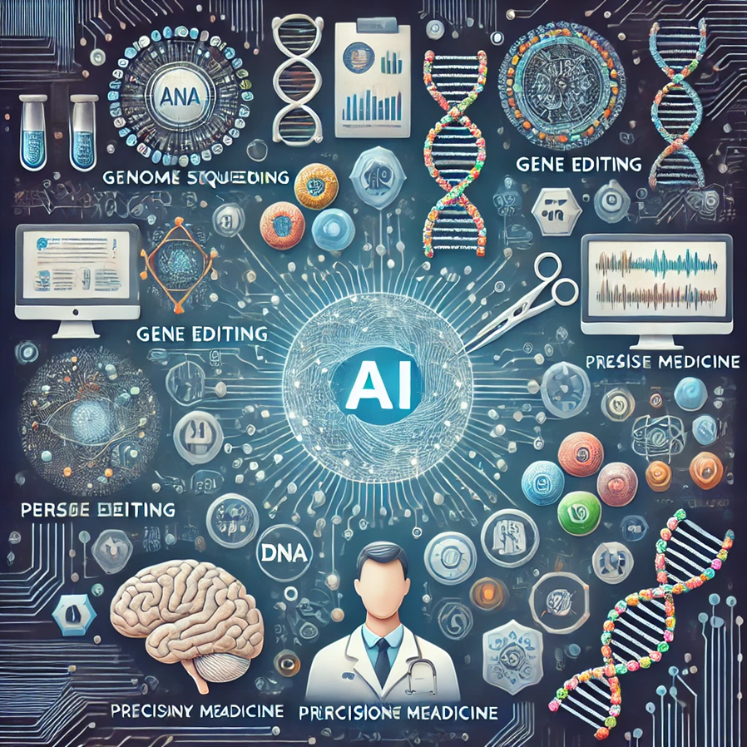

**Figure 1:** The illustration showing the role of Artificial Intelligence (AI) in genetics, highlighting key areas such as genome sequencing, gene editing, precision medicine, and multi-omics integration

**The present role of artificial intelligence in the field of genetics.**

Understanding how genetic information impacts health, disease, and individual responses to treatment is reliant on processing and interpreting genomic data. Due to advances in genome sequencing technologies, there has been an increase in genomic data, requiring sophisticated techniques for handling, examining, and understanding this extensive and intricate information. In Figure 2, we delve into the important stages and obstacles involved in processing and analyzing genomic data.

**Acquisition of Genomic Data**

The process of obtaining genomic data starts with sequencing technologies that convert the DNA sequence into digital data [29]. This is achievable through Whole Genome Sequencing (WGS), which offers the full DNA sequence of an organism's genome. Whole Exome Sequencing (WES) concentrates solely on the exonic (protein-coding) parts, which make up roughly 1% of the genome. Targeted Sequencing focuses on particular genes or regions of interest, like those found in cancer panels. RNA Sequencing (RNA-Seq): Examines the transcriptome, which includes all RNA transcripts generated by the genome, in order to comprehend gene expression. These methods for sequencing produce huge amounts of data that need sophisticated tools and methods to analyze [30].

**Processing of Genomic Data in its Raw State**

After generating sequencing data, various preprocessing steps are needed to guarantee quality and accuracy prior to analysis [31]. This procedure usually involves Quality Control (QC): FastQC and Trimmomatic are tools that examine the raw reads for mistakes, quality of the sequence, and possible contamination. Sequenced reads are aligned to a reference genome by tools such as BWA or Bowtie, to ascertain their specific location in the genome. Variant Calling involves identifying differences such as mutations, insertions, deletions, or structural variants between an individual's genome and the reference genome. GATK and FreeBayes are often utilized tools for this particular task. Normalization: Guaranteeing uniformity in data, especially in handling various sequencing batches or datasets. Genomic data is vast, and compression methods like CRAM format assist in maintaining storage needs while preserving essential information [31].

**Annotation of data**

Following preprocessing, genomic variants must be annotated in order to comprehend their potential effects. Annotation includes: Functional Annotation determines the biological functions of the genomic areas impacted (e.g., which genes or regulatory elements are influenced by a mutation). Clinical Annotation: Connects discovered variants with recognized clinical conditions or traits [32]. ANNOVAR, SnpEff, and ClinVar databases offer connections between genetic variations and illnesses. Pathway and Network Analysis aids in comprehending the interactions between various genes and their products (proteins), typically utilizing platforms such as Reactome or KEGG. Annotation is important for connecting genetic variations to potential biological and clinical importance, aiding in prioritizing variants for further study [33].

**Analysis of Genetic Information**

Converting variant and annotation information into actionable insights for research or clinical purposes is necessary in the interpretation of genomic data. Analysis can center on various aspects, such as detecting mutations that can lead to diseases like cancer or inherited conditions. Pharmacogenomics involves investigating how a person's genetic makeup impacts how they react to medications, such as determining the impact of certain gene variants like CYP2D6 or TPMT on drug processing. Combining numerous genetic variants to create a score that predicts the likelihood of developing a complex disease like cardiovascular disease or diabetes is known as Polygenic Risk Scores (PRS) [48]. Studying how genetic predispositions and environmental factors (like diet and lifestyle) work together to cause disease is called gene-environment interactions.

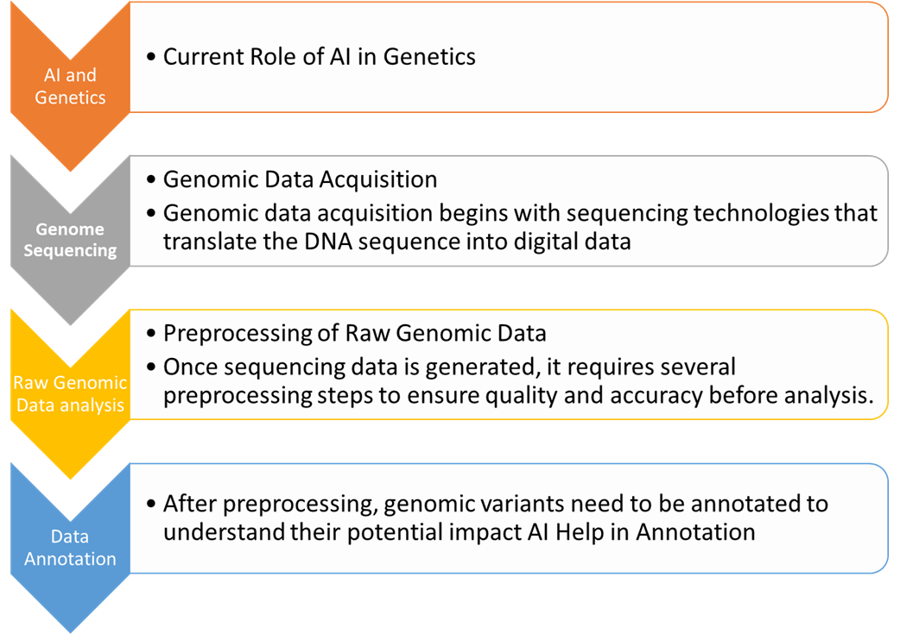

**Figure 2:** The role of AI in Genetic Analysis.

**Tools in bioinformatics for interpreting genomic data.**

Bioinformatics tools and platforms play a vital role in incorporating and analyzing genomic data. Certain important categories involve: Variant interpretation tools such as VEP (Variant Effect Predictor) and SnpEff forecast the effects of variants on protein function [40]. Tools for pathway enrichment, such as DAVID or Gene Ontology tools, pinpoint pathways affected by genetic variants in a significant manner. AI and machine learning algorithms are being more frequently utilized to uncover patterns in genomic data that may be overlooked by humans, forecasting disease susceptibility, treatment reactions, or unidentified genetic correlations [41]. These instruments aid researchers and clinicians in identifying significant patterns in large genomic datasets and connecting them to phenotypes, drug reactions, or potential therapeutic objectives (Table 1).

**Table 1.** AI-powered software is transforming genetic analysis by enhancing the accuracy, speed, and depth of data interpretation. These tools are used in various applications such as variant detection, functional annotation, drug discovery, and predicting disease risks based on genetic data.

|  |  |  |
| --- | --- | --- |
| Serial No | Name Software | Function |
| 1 | DeepVariant (Google AI) | Purpose: Variant calling, detecting mutations, insertions, and deletions in genomes |
| 2 | GATK (Genome Analysis Toolkit) | Purpose: Variant discovery and genotyping. |
| 3 | Mendel AI | Purpose: Automated diagnosis and interpretation of genetic data. |
| 4 | Eagle Genomics | Purpose: Multi-omics data integration and analysis. |
| 5 | GenePattern | Purpose: Functional genomics and integrative data analysis. |
| 6 | SOPHiA GENETICS | Purpose: Data-driven medicine, genomic data analysis, and clinical diagnostics. |
| 7 | AlphaFold (DeepMind) | Purpose: Protein structure prediction based on genetic sequences. |
| 8 | VariantWire | Purpose: Genomic data annotation and interpretation. |
| 9 | CADD (Combined Annotation Dependent Depletion) | Purpose: Variant effect prediction. |
| 10 | PheWAS (Phenome-Wide Association Study) Tools | Purpose: Identifying genotype-phenotype relationships. |

**Challenges in the Processing and Analysis of Genomic Data**

The size and intricacy of data: Genomic datasets are huge, and effectively processing them needs significant computational power [42]. In addition, understanding the significance of changes - especially in areas that are not well-understood such as exons - continues to be difficult. Integrating genomic data with other kinds of data such as proteomics, metabolomics, and clinical data poses a major challenge for obtaining more thorough insights. The protection of genomic data is crucial due to its highly personal nature, especially in healthcare environments, where preventing unauthorized access is essential [43]. Standardization remains a priority in developing uniform genomic data formats and analysis pipelines to maintain consistency and reproducibility in both research and clinical settings [43]. Variants of Unknown Significance (VUS): Numerous identified variants do not have a recognized effect on health, which complicates interpretation [43]. Continued research and sharing of data are needed to enhance our comprehension of these variations.

**Advanced personalized medical treatment techniques**

AI is changing personalized or precision medicine by customizing healthcare according to a person's genetic information [44]. AI can use genetic profiles to forecast how patients will react to certain drugs, which can enhance treatment effectiveness by minimizing trial-and-error methods. AI models are being utilized in Cancer Genomics to forecast the outcomes and reaction to treatment in cancer patients by analyzing genetic mutations, like those present in tumor cells [46]. This involves discovering potential biomarkers for immunotherapy.

**CRISPR and genetic editing technology**

AI greatly enhances gene-editing methods, especially in the CRISPR-Cas9 system, which has transformed genetic manipulation. AI tools use predictive off-target effects to enhance the precision of genome editing with CRISPR by designing more efficient guide RNAs, leading to increased accuracy. Improving Gene Therapy: AI algorithms can simulate different factors impacting gene delivery and editing effectiveness, aiding in creating gene therapies with less unexpected outcomes

**Prediction of diseases using artificial intelligence**

AI models have the ability to analyze extensive genetic information in order to forecast an individual's likelihood of genetic illnesses. Polygenic Risk Scores (PRS): AI assists in computing PRS by combining numerous genetic variations to evaluate the likelihood of developing complex illnesses such as cardiovascular disease, diabetes, and schizophrenia. These scores play a crucial role in early detection and treatment. AI can support genetic counselors in giving more precise risk evaluations for hereditary conditions, aiding in family planning or disease prevention strategies [50].

**Integrating multiple omics datasets.**

AI enables the merging of genomic, transcriptomic, proteomic, and epigenomic data to achieve a comprehensive comprehension of biological systems. AI supports in unraveling the intricate connections between genes and the environment causing diseases such as cancer, neurodegenerative disorders, and autoimmune diseases by combining different 'omics' layers for complex disease analysis [51].

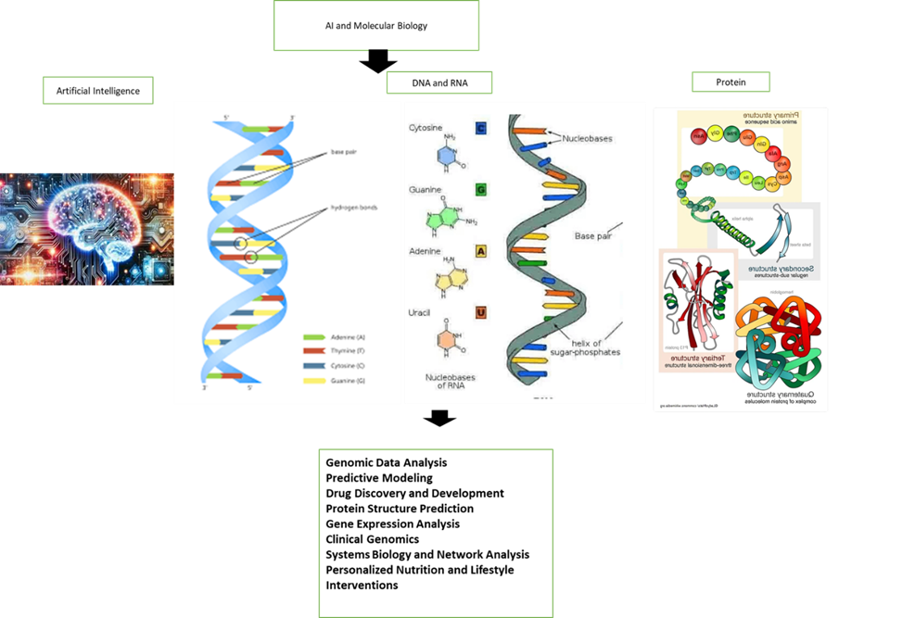

**Figure 3:** AI is catalyzing advancements in genetics by making data analysis faster and more precise, enabling better predictions, and enhancing therapeutic and diagnostic applications. Its integration with genetics promises groundbreaking advancements in human health, agriculture, and environmental sustainability.

**Future direction**

Artificial intelligence is becoming essential for the analysis of intricate genomic data. AI is capable of discovering new connections between different variations and illnesses, streamlining annotation procedures, and forecasting the effects of variations more precisely. Future trends in genomics will include integrating genetic information with proteomics, metabolomics, transcriptomics, and microbiome data to gain a comprehensive understanding of biology and disease. Breakthroughs in cloud computing and faster gene sequencing technologies will allow for immediate analysis of genetic data, especially in clinical situations like customized cancer therapy or quick identification of genetic disorders in infants.

AI will advance the development of CRISPR and other gene-editing tools by improving the accuracy of edits and reducing off-target effects. Future AI-powered systems could potentially enable continuous monitoring of gene-editing results, improving safety levels in clinical use [53]. Anticipating Future Impact: AI has the potential to forecast the lasting outcomes of genetic modifications, aiding in the prediction of potential side effects or the emergence of unexpected characteristics over multiple generations [55]. AI will continue to combine genetic data with environmental, lifestyle, and medical data to provide customized healthcare services in the future. AI-driven health monitoring systems could utilize genetic data to continually evaluate an individual's disease risk, enabling early interventions before symptoms appear. AI algorithms will help quickly interpret genetic tests, allowing for immediate genetic analysis at doctor appointments.

The ability of AI to analyze huge datasets will play a crucial role in the fields of population genetics and evolutionary studies, particularly with the increasing availability of genomic data from various populations worldwide. AI models could potentially provide more precise interpretations of human evolutionary history through the examination of ancient DNA and its comparison with present-day populations. The use of AI in public health can help identify genetic patterns linked to disease outbreaks, assisting in predicting pandemics and shaping global health strategies. AI will play a key role in designing synthetic organisms by aiding scientists in comprehending and controlling genetic networks in order to develop fresh biological systems. AI in Bioengineering: AI will assist in the creation of tailored organisms for activities like developing biofuels, medications, and agricultural improvements. It will enable quick development and experimentation with artificial gene networks [58].

With the increasing popularity of genetic editing, artificial intelligence can also assist in overseeing and upholding ethical standards [59]. AI technology in the field of bioethics can aid in forecasting and simulating the societal effects of genetic advancements, offering support to decision-makers and moral thinkers in addressing intricate issues concerning genetic privacy, human enhancement, and gene therapy [60]. The potential of AI and quantum computing working together is promising in genetics, especially for analyzing intricate biological data like protein folding, genetic regulation networks, and evolutionary dynamics [61]. Quantum Genomics: By processing large datasets quickly, quantum AI has the potential to revolutionize the understanding of genetic disorders, enhancing drug design and evolutionary research.

**Brief overview**

AI is causing a significant change in genetics by transforming the analysis, interpretation, and application of genetic data in research and clinical environments. With the rapid growth of genomic data from technologies like NGS, traditional bioinformatics methods are finding it challenging to handle the increasing complexity and volume. AI, especially with the use of machine learning (ML) and deep learning (DL) methods, is increasingly necessary for efficiently handling this large quantity of data. At present, AI is making great strides in enhancing genome sequencing, identifying genetic variants, and annotating functionality. It is also improving precision medicine by customizing healthcare according to personal genetic information, anticipating how patients will react to medications, and offering knowledge about disease susceptibility. AI has advanced gene-editing technologies such as CRISPR-Cas9 by enhancing guide RNA design and reducing off-target effects. Using artificial intelligence to combine various types of biological data (genomics, transcriptomics, proteomics, etc.) is allowing for a deeper comprehension of intricate diseases like cancer and diabetes. In the future, AI offers the potential for further progress in personalized medicine, gene therapy, and synthetic biology, allowing for instant monitoring of gene-editing results, the creation of artificial organisms, and the creation of genetic models for public health purposes. Nevertheless, ethical concerns regarding genetic data privacy, AI algorithm bias, and the social impacts of gene-editing technologies have arisen alongside technological advancements, emphasizing the importance of cautious governance. AI is set to play a key role in the future of genetics, leading advancements that will transform genomics, personalized medicine, and bioengineering for many years to come.

**Author Contribution**

Shafee Ur Rehman collected the information and wrote the manuscript. Kudaibergen Osmonaliev Azamat Makambaev and Sanzhar Aknazarov review and edit the final manuscript.

**Conflict of interest**

The authors declares that they have no conflict of interest.

**Funding**

No funding

**References**

1. Xu, Y., Liu, X., Cao, X., Huang, C., Liu, E., Qian, S., Liu, X., Wu, Y., Dong, F., Qiu, C.W., & Qiu, J. (2021). Artificial intelligence: A powerful paradigm for scientific research. The Innovation, 2 (4), 100179.
2. Satam, H., Joshi, K., Mangrolia, U., Waghoo, S., Zaidi, G., Rawool, S., Thakare, R.P., Banday, S., Mishra, A.K., Das, G., & Malonia, S.K. (2023). Next-generation sequencing technology: current trends and advancements. Biology, 12(7), p.997.
3. Abdi, G., Jain, M., Barwant, M., Tendulkar, R., Tendulkar, M., Tariq, M., & Amir, A. (2024). Unveiling the Dynamic Role of Bioinformatics in Automation for Efficient and Accurate Data Processing and Interpretation. In Advances in Bioinformatics. Singapore: Springer Nature Singapore. p. 279-319
4. Chaudhari, J.K., Pant, S., Jha, R., Pathak, R.K., & Singh, D.B. (2024). Biological big-data sources, problems of storage, computational issues, and applications: a comprehensive review. Knowledge and Information Systems.1-51.
5. Jamialahmadi, H., Khalili-Tanha, G., Nazari, E., & Rezaei-Tavirani, M. (2024). Artificial intelligence and bioinformatics: a journey from traditional techniques to smart approaches. Gastroenterology and Hepatology from Bed to Bench, 17(3), 241.
6. Paramesha, M., Rane, N. L., & Rane, J. (2024). Artificial intelligence, machine learning, and deep learning for cybersecurity solutions: a review of emerging technologies and applications. Partners Universal Multidisciplinary Research Journal, 1(2), 84-109.
7. Kumar, D. N., Chowdhary, D. L., Pathuri, T., Katta, P., & Arya, L. (2024, May). AI Enhanced-Smart Genome Editing: Integration of CRISPR-Cas9 with Artificial Intelligence for Cancer Treatment. In 2024 5th International Conference for Emerging Technology (INCET) (pp. 01-06). IEEE.
8. Farooq, M.A., Gao, S., Hassan, M.A., Huang, Z., Rasheed, A., Hearne, S., Prasanna, B., Li, X., & Li, H. (2024). Artificial intelligence in plant breeding. Trends in Genetics.
9. Aluru, KS. (2023) Precision Medicine: Leveraging AI for Personalized Patient Care. International Journal of Advanced Engineering Technologies and Innovations, 1(02), 491-516.
10. Singla, A. (2024). Precision Medicine: Tailoring Treatment to Individual Genetic Profiles. Shodh Sagar Journal for Medical Research Advancement, 1(1), 27-37.
11. Yogeshappa, V. G. (2024). AI-Driven Precision Medicine: Revolutionizing Personalized Treatment Plans―. International Journal of Computer Engineering and Technology (IJCET), 15(5), 2024.
12. Udegbe, F. C., Ebulue, O. R., Ebulue, C. C., & Ekesiobi, C. S. (2024). AI's impact on personalized medicine: Tailoring treatments for improved health outcomes. Engineering Science & Technology Journal, 5(4), 1386-1394..
13. Ali, A. M., & Mohammed, M. A. (2024). A comprehensive review of artificial intelligence approaches in omics data processing: evaluating progress and challenges. International Journal of Mathematics, Statistics, and Computer Science, 2, 114-167.
14. Wu, Y., & Xie, L. (2024). AI-driven multi-omics integration for multi-scale predictive modeling of causal genotype-environment-phenotype relationships. arXiv preprint arXiv:2407.06405.
15. Chakraborty, S., Sharma, G., Karmakar, S., & Banerjee, S. (2024). Multi-OMICS approaches in cancer biology: New era in cancer therapy. Biochimica et Biophysica Acta (BBA)-Molecular Basis of Disease, 1870(5), 167120.
16. Vilhekar, R.S., Rawekar, A. (2024). Artificial intelligence in genetics. Cureus, 16(1).
17. Huo, D., & Wang, X. (2024). A new era in healthcare: The integration of artificial intelligence and microbial. Medicine in Novel Technology and Devices, 100319.
18. Williamson, S. M., & Prybutok, V. (2024). Balancing privacy and progress: a review of privacy challenges, systemic oversight, and patient perceptions in AI-driven healthcare. Applied Sciences, 14(2), 675.
19. Serrano, D. R., Luciano, F. C., Anaya, B. J., Ongoren, B., Kara, A., Molina, G., ... & Lalatsa, A. (2024). Artificial intelligence (AI) applications in drug discovery and drug delivery: revolutionizing personalized medicine. Pharmaceutics, 16(10), 1328.
20. Yingngam, B. (2024). Introduction to Bioinformatics. Artificial Intelligence and Machine Learning in Drug Design and Development, 23-66.
21. Vilhekar, R. S., & Rawekar, A. (2024). Artificial intelligence in genetics. Cureus, 16(1).
22. Chafai, N., Bonizzi, L., Botti, S., & Badaoui, B. (2024). Emerging applications of machine learning in genomic medicine and healthcare. Critical Reviews in Clinical Laboratory Sciences, 61(2), 140-163.
23. Zahra, M. A., Al-Taher, A., Alquhaidan, M., Hussain, T., Ismail, I., Raya, I., & Kandeel, M. (2024). The synergy of artificial intelligence and personalized medicine for the enhanced diagnosis, treatment, and prevention of disease. Drug Metabolism and Personalized Therapy, 39(2), 47-58.
24. Derraz, B., Breda, G., Kaempf, C., Baenke, F., Cotte, F., Reiche, K., ... & Gilbert, S. (2024). New regulatory thinking is needed for AI-based personalised drug and cell therapies in precision oncology. NPJ Precision Oncology, 8(1), 23.
25. Sun, H. (2024). Navigating the CRISPR-Cas9 Frontier: AI-Enabled off-target prediction and sgRNA Design for Unprecedented Precision. Transactions on Materials, Biotechnology and Life Sciences, 3, 522-531.
26. Cannarozzi, A. L., Latiano, A., Massimino, L., Bossa, F., Giuliani, F., Riva, M., ... & Palmieri, O. (2024). Inflammatory bowel disease genomics, transcriptomics, proteomics and metagenomics meet artificial intelligence. United European Gastroenterology Journal.
27. Brlek, P., Bulić, L., Bračić, M., Projić, P., Škaro, V., Shah, N., ... & Primorac, D. (2024). implementing whole genome sequencing (WGS) in clinical practice: advantages, challenges, and future perspectives. Cells, 13(6), 504.
28. Kumar, K. R., Cowley, M. J., & Davis, R. L. (2024, May). Next-generation sequencing and emerging technologies. In Seminars in thrombosis and hemostasis. Thieme Medical Publishers.
29. Coussement, L., Van Criekinge, W., & De Meyer, T. (2024). Quantitative transcriptomic and epigenomic data analysis: a primer. Bioinformatics Advances, vbae019.
30. Chandrashekar, K., Niranjan, V., Vishal, A., & Setlur, A. S. (2024). Integration of artificial intelligence, machine learning and deep learning techniques in genomics: review on computational perspectives for NGS analysis of DNA and RNA seq data. Current Bioinformatics, 19(9), 825-844.
31. Stenton, S. L., & Prokisch, H. (2020). Genetics of mitochondrial diseases: Identifying mutations to help diagnosis. EBioMedicine, 56.
32. Talukder, P., Dutta, A., & Datta, S. (2024). In Vitro Genetic Approach to Identify Disease Gene Mutations. In Exploring Medical Biotechnology-in vivo, in vitro, in silico (pp. 198-205). CRC Press.
33. Carr, D. F., Turner, R. M., & Pirmohamed, M. (2021). Pharmacogenomics of anticancer drugs: Personalising the choice and dose to manage drug response. British Journal of Clinical Pharmacology, 87(2), 237-255.
34. Cacabelos, R., Naidoo, V., Corzo, L., Cacabelos, N., & Carril, J. C. (2021). Genophenotypic factors and pharmacogenomics in adverse drug reactions. International journal of molecular sciences, 22(24), 13302.
35. Abraham, G., Rutten-Jacobs, L., & Inouye, M. (2021). Risk prediction using polygenic risk scores for prevention of stroke and other cardiovascular diseases. Stroke.
36. Truong, B., Hull, L. E., Ruan, Y., Huang, Q. Q., Hornsby, W., Martin, H., ... & Natarajan, P. (2024). Integrative polygenic risk score improves the prediction accuracy of complex traits and diseases. Cell Genomics, 4(4).
37. Chen, A. Y. A., Yuan, T. H., Huang, J. H., Wang, Y. B., Hung, T. M., Chen, C. Y., ... & Chen, P. L. (2024). Toward Automatic Variant Interpretation: Discordant Genetic Interpretation across Variant Annotations for ClinVar Pathogenic Variants. bioRxiv, 2024-10.
38. Clark, A. J., & Lillard Jr, J. W. (2024). A Comprehensive Review of Bioinformatics Tools for Genomic Biomarker Discovery Driving Precision Oncology. Genes, 15(8), 1036.
39. Chaudhari, J. K., Pant, S., Jha, R., Pathak, R. K., & Singh, D. B. (2024). Biological big-data sources, problems of storage, computational issues, and applications: a comprehensive review. Knowledge and Information Systems, 1-51.
40. Garmire, L. X., Li, Y., Huang, Q., Xu, C., Teichmann, S. A., Kaminski, N., ... & Teschendorff, A. E. (2024). Challenges and perspectives in computational deconvolution of genomics data. Nature Methods, 21(3), 391-400.
41. Udegbe, F. C., Ebulue, O. R., Ebulue, C. C., & Ekesiobi, C. S. (2024). AI's impact on personalized medicine: Tailoring treatments for improved health outcomes. Engineering Science & Technology Journal, 5(4), 1386-1394.
42. Hakami, M. A. (2024). Harnessing machine learning potential for personalised drug design and overcoming drug resistance. Journal of Drug Targeting, 32(8), 918-930.
43. Deepali, Goel, N., & Khandnor, P. (2024). Advances in AI-based genomic data analysis for cancer survival prediction. Multimedia Tools and Applications, 1-28.
44. Sun, L., Lai, M., Ghouri, F., Nawaz, M. A., Ali, F., Baloch, F. S., ... & Shahid, M. Q. (2024). Modern Plant Breeding Techniques in Crop Improvement and Genetic Diversity: From Molecular Markers and Gene Editing to Artificial Intelligence—A Critical Review. Plants, 13(19), 2676.
45. Danaeifar, M., & Najafi, A. (2024). Artificial Intelligence and Computational Biology in Gene Therapy: A Review. Biochemical Genetics, 1-24.
46. Liang, L., Chen, Y., Wang, T., Jiang, D., Jin, J., Pang, Y., ... & Zhao, L. (2024). Genetic Transformer: An Innovative Large Language Model Driven Approach for Rapid and Accurate Identification of Causative Variants in Rare Genetic Diseases. medRxiv, 2024-07.
47. Wu, Y., & Xie, L. (2024). AI-driven multi-omics integration for multi-scale predictive modeling of causal genotype-environment-phenotype relationships. arXiv preprint arXiv:2407.06405.
48. Nagarajan, R., Wang, C., Walton, D., & Walton, N. (2024). Artificial Intelligence Applications in Genomics. Advances in Molecular Pathology, 7(1), 145-154.
49. Kaur, R., Mandal, D., Potdar, V., Gosavi, M. S., & Kumar, A. (2024). Multi-omics and Its Clinical Application. In Multi-Omics Analysis of the Human Microbiome: From Technology to Clinical Applications (pp. 295-319). Singapore: Springer Nature Singapore.
50. Dixit, S., Kumar, A., Srinivasan, K., Vincent, P. D. R., & Ramu Krishnan, N. (2024). Advancing genome editing with artificial intelligence: opportunities, challenges, and future directions. Frontiers in Bioengineering and Biotechnology, 11, 1335901.
51. Yildirim, Z., Swanson, K., Wu, X., Zou, J., & Wu, J. (2024). Next-Gen Therapeutics: Pioneering Drug Discovery with iPSCs, Genomics, AI, and Clinical Trials in a Dish. Annual Review of Pharmacology and Toxicology, 65.
52. Zahra, M. A., Al-Taher, A., Alquhaidan, M., Hussain, T., Ismail, I., Raya, I., & Kandeel, M. (2024). The synergy of artificial intelligence and personalized medicine for the enhanced diagnosis, treatment, and prevention of disease. Drug Metabolism and Personalized Therapy, 39(2), 47-58.
53. Dong, H., Lin, J., Tao, Y., Jia, Y., Sun, L., Li, W. J., & Sun, H. (2024). AI-enhanced biomedical micro/nanorobots in microfluidics. Lab on a Chip, 24(5), 1419-1440.
54. Huang, X., Rymbekova, A., Dolgova, O., Lao, O., & Kuhlwilm, M. (2024). Harnessing deep learning for population genetic inference. Nature Reviews Genetics, 25(1), 61-78.
55. Bayan, F.M. (2024). The Ethics of AI: Navigating the Moral Dilemmas of Artificial Intelligence. Arab Journal for Scientific Publishing, 2663, 5798.
56. Mennella, C., Maniscalco, U., De Pietro, G., & Esposito, M. (2024). Ethical and regulatory challenges of AI technologies in healthcare: A narrative review. Heliyon.
57. Bekbolatova, M., Mayer, J., Ong, C. W., & Toma, M. (2024, January). Transformative potential of AI in Healthcare: definitions, applications, and navigating the ethical Landscape and Public perspectives. In Healthcare MDPI, 12(2), 125.
58. Malgieri, G., & Pasquale, F. (2024). Licensing high-risk artificial intelligence: toward ex ante justification for a disruptive technology. Computer Law & Security Review, 52, 105899.
59. Tugui, A., & Zelinschi, D. O. (2024). A New AI Dialogue Framework with ChatGPT: Exploring Synthetic Man within the Context of Synthetic Biology.
60. Pal, S., Bhattacharya, M., Lee, S. S., & Chakraborty, C. (2024). Quantum computing in the next-generation computational biology landscape: From protein folding to molecular dynamics. Molecular biotechnology, 66(2), 163-178.
61. Selladurai, P., Dahiya, R., Kandasamy, B., & Radhakrishnan, V. (2024). Integrating Quantum Computing in Bioinformatics and Biomedical Research. Intelligent Data Analytics for Bioinformatics and Biomedical Systems, 357-380.